Deutscher Caritasverband e.V.
Referat Migration und Integration
Karlstraße 40, 79104 Freiburg
Contact: Vanessa Zehnder
Phone: 0761 200-430
vanessa.zehnder@caritas.de

Caritasverband für die
Diözese Hildesheim e.V.
Caritasstelle im
Grenzdurchgangslager Friedland
Heimkehrerstraße 11, 37133 Friedland
Contact: Eva Lutter / Johanna Hamoodi
Phone: 05504 9493664
lutter@caritasfriedland.de
hamoodi@caritasfriedland.de

Date 10th June 2017

Project description
resettlement.de
Strengthening of communication and support
structures within the reception process

Project duration

26th June 2015 – 25th June 2018
PROJECT GOALS
Based on the above this project in cooperation of Caritas of the Diocesan Hildesheim and Caritas Germany aims to achieve the following:

- All actors involved in the reception and integration process have received early notification about relevant aspects.

- The set-up of local and regional support networks for refugees is promoted.

- Opportunities for new arrivals to benefit from the experiences of previous arrivals have been created.

background
Resettlement and humanitarian admission contribute to take responsibility in protracted and urgent refugee situations, in cases when voluntary return to the country of origin or integration in the country of first reception is not an option. Legal and safe access is granted through direct admission of the refugees (mostly registered by UNHCR) into the receiving country.

- Currently Germany admits 500 refugees annually through the UNHCR resettlement program. In addition, Germany offers 300 resettlement places under the European program.

- From 2013-2015 humanitarian admission programmes allowed temporary admission of 20,000 refugees from Syria. Further, federal states have created admission programmes offering legal entry to Syrian nationals with relatives in Germany. Similarly, Private Sponsorship Refugee Programmes offer privately financed admission of refugees and are currently under discussion.

- Relocation programmes aim at redistributing refugees among the European member states. In 2011 Germany participated for the first time by relocating individuals from Malta.

Local actors and especially the civil society, e.g. welfare organisations including their migration counselling services, could contribute and be involved to a larger extend. An approach is early communication and improved communication channels regarding expected new arrivals.

Project Activities

Besides refugees, politics and administration (e.g. Federal Office for Migration, Ministry of the Interior) the project addresses especially the civil society as well as local actors.

We support you…
- … through the website www.resettlement.de providing extensive background information regarding the different admission programmes, relevant actors and legal frameworks
- … with a newsletter including recent developments and events concerning the subject of resettlement and humanitarian admission
- … by hosting an annual event and several regional conferences with a special focus on this subject
- … as speakers with tailored input to resettlement and humanitarian admission at your conference in the context of refugees and asylum
- … in cases of general questions regarding admission procedures as well as the legal and social frameworks

Please also contact us…
- … providing questions, your experiences and suggestions concerning the subject of resettlement and humanitarian admission

contact

Deutscher Caritasverband e.V. Caritasverband für die Diözese Hildesheim e.V.
Referat Migration und Integration Caritasstelle im Grenzdurchgangslager Friedland
Vanessa Zehnder Eva Lutter / Johanna Hamoodi
Phone 0761 200-430 Phone 05504 9493664
E-Mail vanessa.zehnder@caritas.de E-Mail lutter@caritasfriedland.de
hamoodi@caritasfriedland.de

ATCR Co-Chair: ATCR Co-Chair:
Deutscher Caritasverband e.V. Deutscher Caritasverband e.V.
Referat Migration und Integration Referat Migration und Integration
Patricia Reineck Elena Knežević
Phone 0761 200-582 Phone 0761 200-370
E-Mail patricia.reineck@caritas.de E-Mail elena.knezevic@caritas.de

This project is co-financed by the Asylum, Migration and Integration Fund.
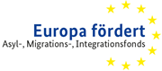
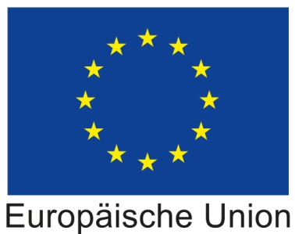
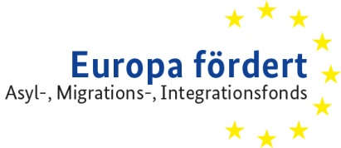

Individual counselling and advice cannot be provided with in the scope of this project. Please contact your local migration service. Further, we are not entitled to receive recommendations for admitting individual refugees to Germany.

